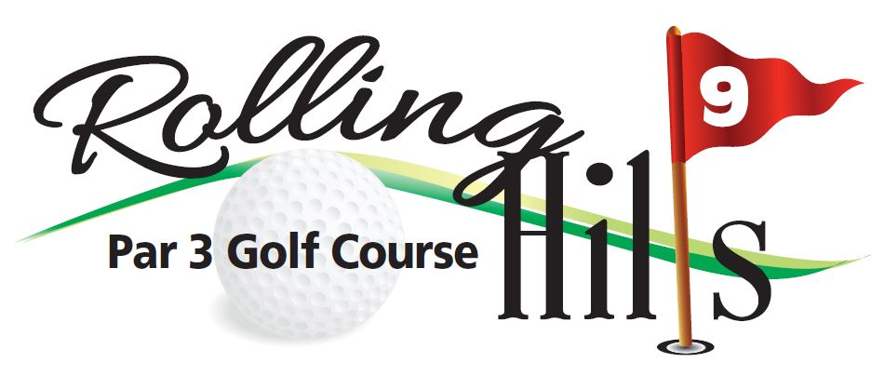

2022 Tuesday Night Men’s League at Rolling Hills Par 3
- Schedule May 17 through August 16
Every Tuesday 14 Weeks
August 23st End of season tournament (5:30 shot-gun start)
August 23st Banquet after the tournament at Rolling Hills
- Tee Times After 3 PM – Tee times are not reserved
- Fees $60 ( plus weekly golf fees)
Must be paid by 3rd week (May 29)
Greens fee rate $15 Walk, $20 Ride
Includes Weekly cash payout for low score with handicap
Awards Banquet / Steak dinner!!
- Closest to the Pin $1 each week (optional) will carry over
Turn score card in, sign and date
- Make-up Rounds Scorecards must be turned in by noon the following Tuesday – NO EXCEPTIONS
- Rainouts Determined by the course at 3:00 PM. We will annonce on Facebook and website.
If course is open, the league is expected to play, if course is closed the week is skipped for all, no make-ups!
2022 Tuesday Night Men’s League at Rolling Hills Par 3
- All Golfers must use WHITE TEES
- NO “GIMMEE” putts
- No “Mulligans”
- PLAY THE BALL WHERE IT LIES- Use clean and place approach when coarse is extremely wet
- HOLE # 1, 2, 4, & 6 Out of bounds areas are marked with White Stakes. If your ball lands in the marked area, another ball must be hit from the point where the ball was originally struck and you lose the stroke and distance. A provisional ball may be played if you are unsure the ball went out of bounds. If it did not go out of bounds, pick up the provisional ball and play the original ball.
- Hole # 8 & 5 hazards are marked with red stakes. If your ball lands in the marked area or any other natural hazard (woods, water, etc.), drop another ball on the flight line where the original ball entered the hazard, within two club lengths of the hazard, with NO advancement. A penalty stroke must be taken.

CONTACT: Rolling Hills (716) 496-5016 – course status and cart reservation

